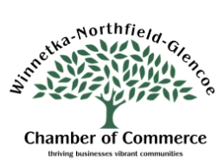
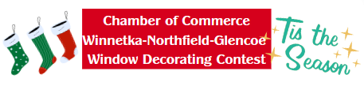
Application Form

Applicant Name_______________________________________________
Business Name_______________________________________________
Address______________________________ City___________________
Phone__________________________ Email_______________________

Residents will begin voting November 24 through January 3 via QR code on posters or ballots placed at your business. (Posters and voting forms will be provided to you.)
Winners will be announced on January 7, 2025. A perpetual trophy will be awarded to all winners in Winnetka, Northfield and Glencoe that will include your business name and year you won! You will have bragging rights and have custody of the trophy for the year. All three winners will also receive a gift certificate from a local restaurant.
Congratulations to our 2023 winners:
Figueroa Orthodontics in Winnetka
Children’s Gift Shop in Northfield
The Wild Child in Glencoe!

Please return this application form to:
Winnetka-Northfield-Glencoe Chamber of Commerce, 841 Spruce Street, Winnetka, IL 60093
Email: wcc@wngchamber.com or via Fax: (847) 446-4452 or sign up online (via our events calendar – event starts November 24). For more information contact the Chamber office at (847) 446-4451 or wcc@wngchamber.com

