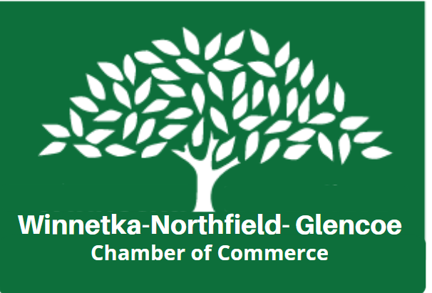
Welcome to the
2024 Winnetka-Northfield Sidewalk Sale
Winnetka: 9 a.m. – 5 p.m. ● Friday, July 19 & Saturday, July 20
Northfield 10 a.m. – 5 p.m. ● Friday, July 19 & Saturday, July 20
Sponsored by:
Winnetka-Northfield Sidewalk Sale!
Space is available for Winnetka-Northfield Chamber Members in
their respective villages and Non-Members only in the three Winnetka commercial business districts: Hubbard Woods, East Elm and West Elm.

During this multiple day event, the Winnetka-Northfield-Glencoe Chamber purchases additional insurance required by the Village of Winnetka for a special use permit to use the sidewalks. All businesses located within the sidewalk sale areas must pay the appropriate fees listed in this application or may find the sidewalk space in front of their business assigned to fee-paying vendors. Proceeds from this event will be used to expand the benefits and services provided to chamber members and the community.
Additional details:
- SWS Sponsorship: Include your logo on promotional materials and advertisements Cost: $500.
- Set-Up: Set-up for Winnetka locations – must be before 8:45 am.
- Spaces Are Not Uniform in Size or Shape. Spaces may have awnings overhead, planters or benches on the ground. DO NOT MOVE PLANTERS OR BENCHES. Only the Winnetka-Northfield Chamber of Commerce has the sole authority to assign and specify vendor locations. We reserve the right to ask vendors to move or withdraw if they are not in their assigned location or following the allocated contractual space requirements.
- Tents/Umbrellas/Awnings: If you plan on using a tent or awning, you will receive special placement in Hubbard Woods Park. Tent spaces will be assigned.
- Helium Tanks: must be pre-approved by the Fire Inspector and tightly secured.
- Merchandise & refuse: Vendors must remove all refuse, merchandise, and display pieces every night. WNG Chamber of Commerce does not provide for overnight storage or security.
- Parking: Vendors should park in non-commercial districts or residential districts.
- Rain: The Sidewalk Sale will take place, Rain, or Shine. NO Refunds will be given.

Complete pages 2 and 3 with all fees and return to the Chamber of Commerce office by 7/5/24 to receive the discounted fee. After July 5th the discount will no longer apply.
Questions: (847) 446-4451; email: wcc@wngchamber.com; Fax: 847-446-4452.
841 Spruce Street, Suite 204, Winnetka, IL 60093

2024 Sidewalk Sale Application Friday, July 19th & Saturday, July 20th
(Winnetka and Northfield)
Name of business: _____________________________Contact Person: ___________________________
Address: _________________________________City: ________State: Zip: _________
Phone: _____________________Fax: ______________________ Cell Phone: ______________________
Email: _______________________________________________________________________________
Describe any food offering: ____________________________________________________________
(Note: ANY FOOD OFFERING requires NOTIFYING THE HEALTH DEPARTMENT AND COMPLETING TEMPORARY FOOD PERMIT APPLICATION, refrigeration required)

WNG Chamber Member Rates – No Refunds
Yes, I will use the sidewalk in front of my business at the above address.
I need a location OR a 2nd location: Hubbard Woods West Elm East Elm

Sidewalk Sale Fee before 7/5 $140 $ ____
Sidewalk Sale Fee After 7/5 $165 $ ____
Not for Profit ONLY Fee before 7/5 $100 $ ____
Not-for-Profit ONLY After 7/5 $125 $ ____
Sidewalk Sale Sponsor $500 $ ____
Grand Total $ _____

Rentals (CHAMBER MEMBERS ONLY)
Equipment rental is available to Members ONLY. The Chamber is not responsible for the condition of rental equipment. Deliveries will be made Thursday, July 18th and cannot be changed. Please check your order immediately. On Saturday evening July 20th, return all items to the exact location where they were delivered. Fold your tables, chairs, and racks. Remove the masking tape with your business name from all equipment. Equipment will be collected early Sunday morning, July 21st. You will be responsible for the cost of any lost/stolen items.
8 feet x 2 ½ feet TABLES $25 each $ ____
4 feet double bar/wheels CLOTHES RACK $55 each $ ____
5 feet single bar/wheels CLOTHES RACK $55 each $ ____
Folding chair $ 5each $ ____
Grand Total $ _____

Non-Member Rates – (No Refunds)
Location request: Hubbard Woods Hubbard Woods Park with Tent West Elm East Elm
Detailed description of items or products for sale or giveaway (Include brand names, price range, and any other information): ___________________________________________________________
Check one: Retailer Service Provider Not-for-profit Food Vendor Entertainer

Space allocations have been increased to accommodate all outside vendors. All vendors will be held accountable for space requested in the SWS contract. If you take more space than requested in your contract, you will be required to pay for additional space at the time the chamber representative checks you in on Friday and Saturday. We ask that you follow the instructions on space and payment requirements.

Single space/2days (10’ space) Fee before 7/5 $275 $ ______
Single space/ 2 days (10’space) After 7/5 $300 $ ______
Double space/2 days (20’ space) Fee before 7/5 $310 $ ______
Double space/2days (20’space) After 7/5 $335 $ ______

2024 Sidewalk Sale Application/Friday, July 19 & Saturday, July 20
(Winnetka and Northfield)
Non-member rates continued for NON-PROFIT ONLY:
Not for Profit ONLY single space/2days fee before July 5 $125 $ ______
Not-for-Profit ONLY single space/2days after July 5 $150 $ ______

Grand Total $ ______

Children’s Entrepreneur Participation
Students are invited to be entrepreneurs and sell hand-made items or services at the Winnetka-Northfield Sidewalk Sale. Your location will be in Hubbard Woods Park. You may bring a tent, or umbrella along with your own table and chairs. You will receive your assigned location at 8:00 a.m. Friday morning from a Chamber Representative.

Name: ______________________________________________________________ Age: _________
Address: ________________________________City: ______ Cell Phone: ______________
Email: ______________________________________________________________________________
Please describe what will be sold: ________________________________________________________
Parent signature (required if child is under the age of 18): ____________________________________
Children’s Entrepreneur Booth $25 $ _____
GRAND TOTAL $ ______
SPACE LOCATIONS WILL BE SENT BY 7/17/24
Winnetka-Northfield-Glencoe Chamber of Commerce, 841 Spruce Street, #204 Winnetka, IL 60093
Fax (847) 446-4452
Visa/ MasterCard/Discover/AMEX: Credit Card Number: _ _ _ _ -- _ _ _ _ -- _ _ _ _ -- _ _ _ _
Exp. _ _ / _ _ Security -Code _ _ _
I have read and agree to abide by the Sidewalk Sale rules and regulations in their entirety and acknowledge full responsibility for all activities conducted throughout the term of this permit. Additionally, I agree to hold the Winnetka-Northfield-Glencoe Chamber of Commerce harmless, and to indemnify the Winnetka-Northfield-Glencoe Chamber of Commerce for all claims of whatever kind or nature which might be made against the Winnetka-Northfield-Glencoe Chamber of Commerce due to my participation in the Sidewalk Sale.
DATE: _______PRINT NAME: __________________________SIGNATURE: _______________________
The Winnetka-Northfield-Glencoe Chamber of Commerce
841 Spruce Street, Suite 204 Winnetka, IL 60093 847-446-4451

